Project name : Weather Station Monitoring Using IOT

List of required hardware components
1. stm32
2. ESP8266 WiFi Module
3. DHT11
4. Soil moisture sensor
5. Rain Sensor
6. 16*2 LCD Display
7. Beard Board
8. Jumper Wire
9. Data Cable

Details of Hardware Component

1 STM32F407 :

The STM32F4DISCOVERY Discovery kit allows users to easily develop applications with
the STM32F407VG high-performance microcontroller with the Arm® Cortex®-M4 32-bit
core. It includes everything required either for beginners or experienced users to get started
quickly.

Based on STM32F407VG, it includes an ST-LINK/V2-A embedded debug tool, one ST-
MEMS digital accelerometer, one digital microphone, one audio DAC with integrated class D
speaker driver, LEDs, push-buttons and a USB OTG Micro-AB connector. Specialized add-
on boards can be connected by means of the extension header connectors. The
STM32F4DISCOVERY Discovery kit comes with the STM32 comprehensive free software
libraries and examples available with the STM32CubeF4 MCU Package.

Figure 1. STM32F4DISCOVERY
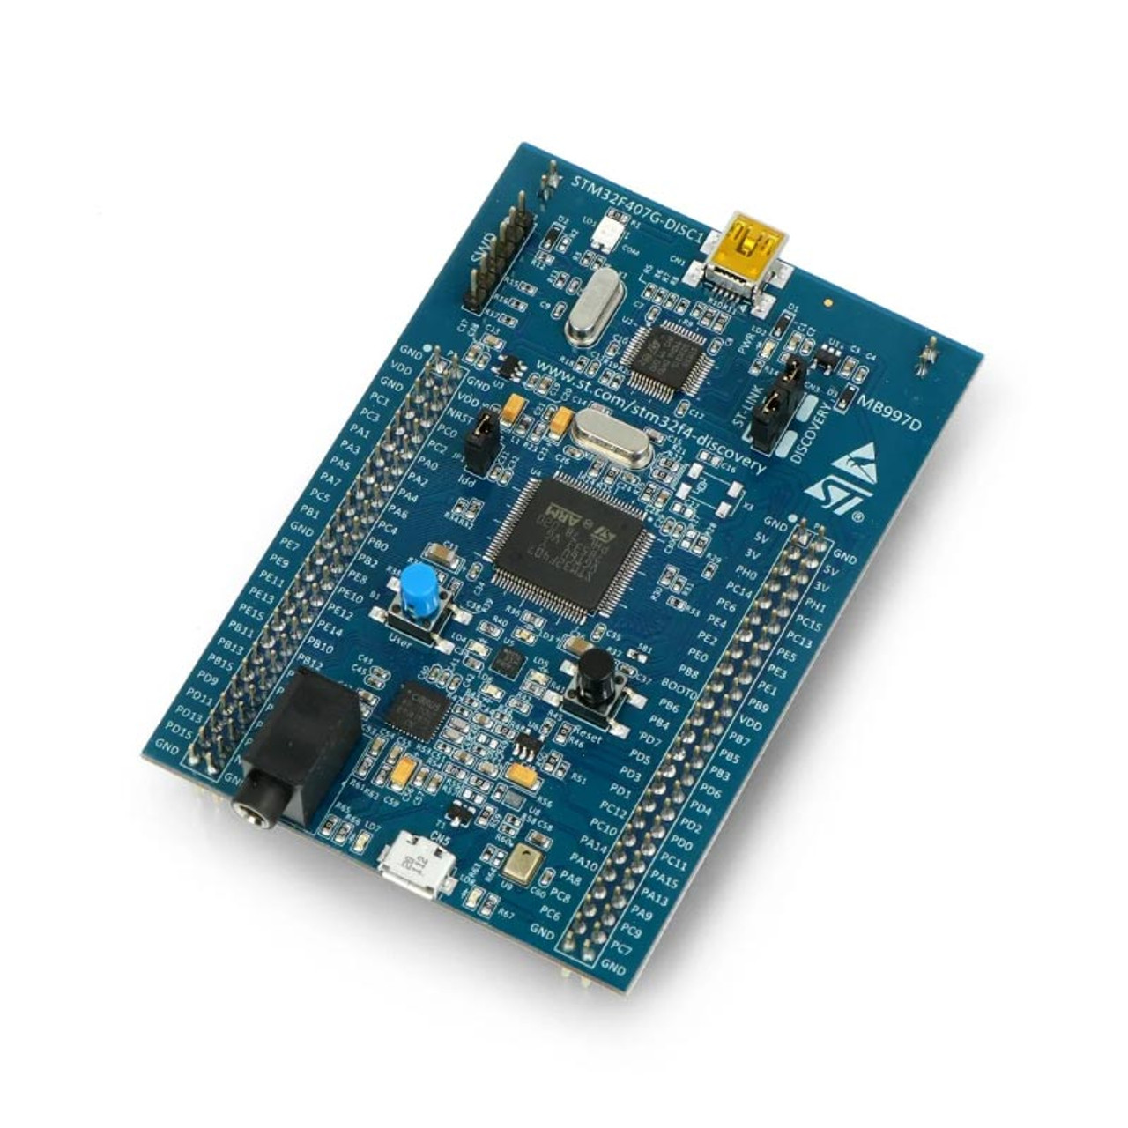

2 ESP8266 – Wi-Fi Module

The ESP8266 WiFi Module is a self-contained SOC with in an integrated TCP/IP protocol
stack that can give any microcontroller access to your WiFi network. The ESP8266 is
capable of either hosting an application or offloading all Wi-Fi networking functions from
another application processor. Each ESP8266 module comes pre-programmed with an AT
command set firmware, meaning, you can simply hook this up to your Arduino device and
get about as much WiFi-ability as a WiFi Shield offers (and that’s just out of the box)! The
ESP8266 module is an extremely cost-effective board with a huge, ever -growing,
community.

Fig – 2 ESP8266 WiFi Module
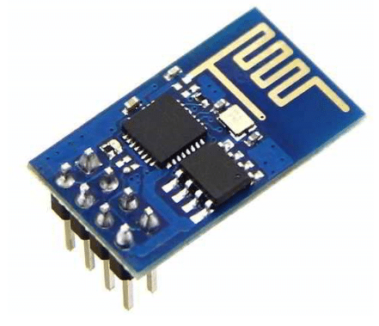

3 DHT11(Temperature & Humidity sensor)

The DHT-11 Digital Temperature and Humidity Sensor is a basic, ultra-low-cost digital
temperature and humidity sensor. It uses a capacitive humidity sensor and a thermistor to
measure the surrounding air and spits out a digital signal on the data pin (no analog input pins
needed).

DHT11 Specifications:
- Operating Voltage: 3.5V to 5.5V
- Operating current: 0.3mA (measuring) 60uA (standby)
- Output: Serial data
- Temperature Range: 0°C to 50°C
- Humidity Range: 20% to 90%
- Resolution: Temperature and Humidity both are 16-bit
- Accuracy: ±1°C and ±1% as shown below in figure 3.

Fig – 3 DHT11(Temperature & Humidity Sensor)

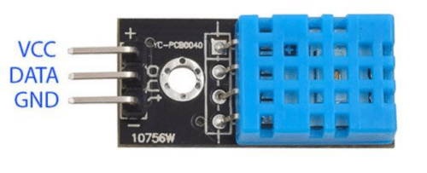

4 Soil Moisture Sensor:

Soil moisture is basically the content of water present in the soil. This can be measured using a soil moisture sensor which consists of two conducting probes that act as a probe. It can measure the moisture content in the soil based on the change in resistance between the two conducting plates. The resistance between the two conducting plates varies in an inverse manner with the amount of moisture present in the soil as shown in figure 3.

Fig. 3: Soil Moisture Sensor
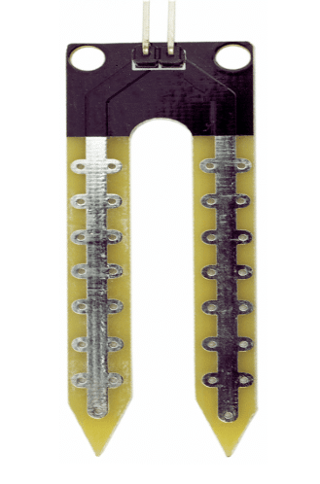

4. Rain Sensor
A rain sensor is one kind of switching device which is used to detect the rainfall. It works
like a switch and the working principle of this sensor is, whenever there is rain, the switch
will be normally closed.

4.1. Rain Sensor Module
The rain sensor module/board is shown below. Basically, this board includes nickel coated
lines and it works on the resistance principle. This sensor module permits to gauge moisture
through analog output pins & it gives a digital output while moisture threshold surpasses.
This module is similar to the LM393 IC because it includes the electronic module as well as a
PCB. Here PCB is used to collect the raindrops. When the rain falls on the board, then it
creates a parallel resistance path to calculate through the operational amplifier.

4.2. Pin Configuration
The pin configuration of this sensor is shown below. This sensor includes four pins which
include the following.

Pin1 (VCC): It is a 5V DC pin
• Pin2 (GND): it is a GND (ground) pin
• Pin3 (DO): It is a low/ high output pin
• Pin4 (AO): It is an analog output pin

4.2. Specification of Rain Sensor
• This sensor module uses good quality of double-sided material.
• Anti-conductivity & oxidation with long time use
• The area of this sensor includes 5cm x 4cm and can be built with a nickel plate on the side
• The sensitivity can be adjusted by a potentiometer
• The required voltage is 5V
• The size of the small PCB is 3.2cm x 1.4cm
• For easy installation, it uses bolt holes
• It uses an LM393 comparator with wide voltage
• The output of the comparator is a clean waveform and driving capacity is above 15mA

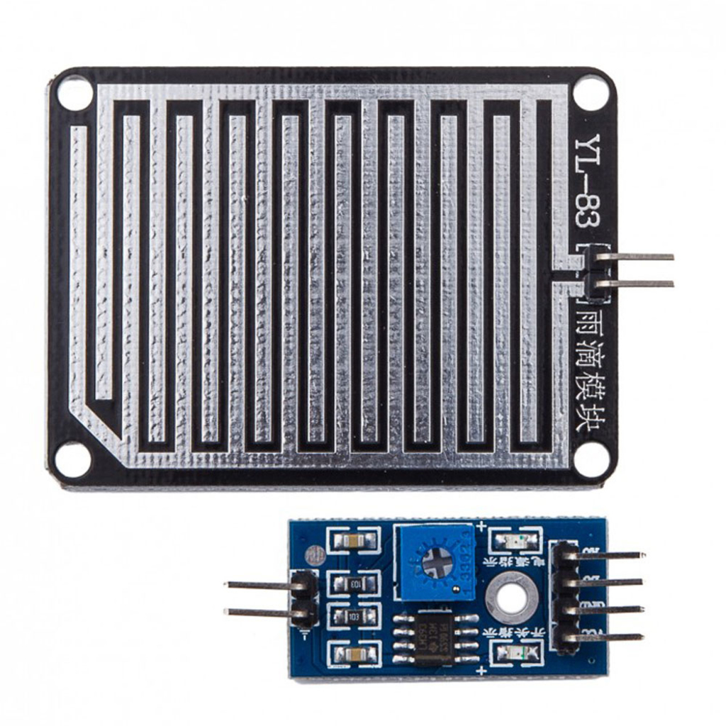
Fig – 4 Rain Sensor with Module

5 LCD Display
A Liquid Crystal Display commonly abbreviated as LCD is basically a display unit built
using Liquid Crystal technology. When we build real life/real world electronics - based
projects, we need a medium/device to display output values and messages. The most basic
form of electronic display available is 7 Segment displays – which has its own limitations.
The next best available option is Liquid Crystal Displays which comes in different size
specifications. Out of all available LCD modules in market, the most commonly used one is
16×2 LCD Module which can display 32 ASCII characters in 2 lines. To establish a good
communication between human world and machine world, display units play an important
role. And so, they are an important part of embedded systems. Display units - big or small,
work on the same basic principle. Besides complex display units like graphic displays and 3D
display, one must know working with simple displays like 16x1 and 16x2 units.

Fig – 5 16*2 LCD Display

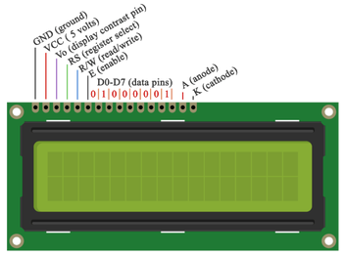

Block Diagram :

ThingSpeask
server
ESP8266
WIFI
Rain senser
DHT11
Soil
Sensor
STM32

LCD

Power
supply

Flow chart of the system

Start Process

Open serial monitor & see
Wi-Fi is connected or not
Connect all the sensors with microcontroller(ESP8266wifi)
Sensor like temperature and humidity,rain sensor , soil sensor
Write the code on Ardunio IDE and import the
related library in Arduino ide
Upload the code on Arduino IDE
After Uploading is connected with wifi and provide an IP address
It will display the real time data on cloud using thinkspeak platfrom and
Also see on lcd connect on hardware
End Process

If yes

If no

Check connection and
Ssid and password

